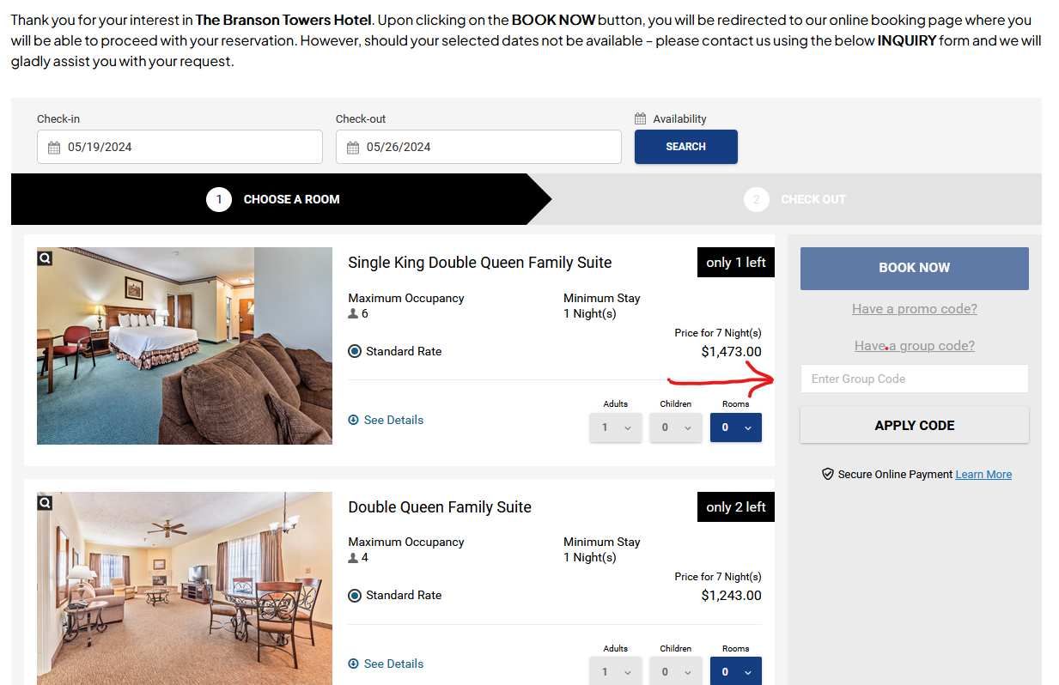

On the website: www.thebransontowers.com
Click on “Book Now”
Click on “Have a group code”
Enter the code: b624062 Then apply code
Prices will adjust automatically
Price for King and Queen rooms should be $80 per night
There are 2 of each of the suite class rooms. They are available on first come first serve basis.

